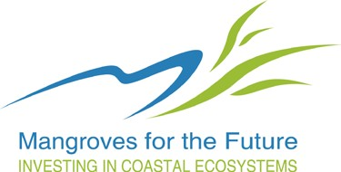

Mangroves for the Future
Reporting Templates for Small Grant Facility

Document Version: 18 February 2014

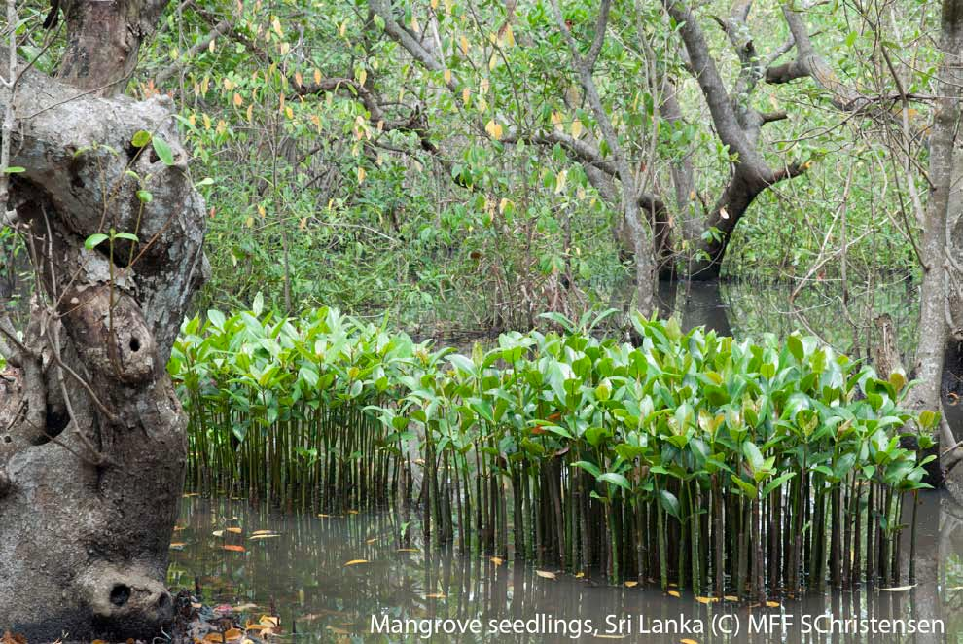

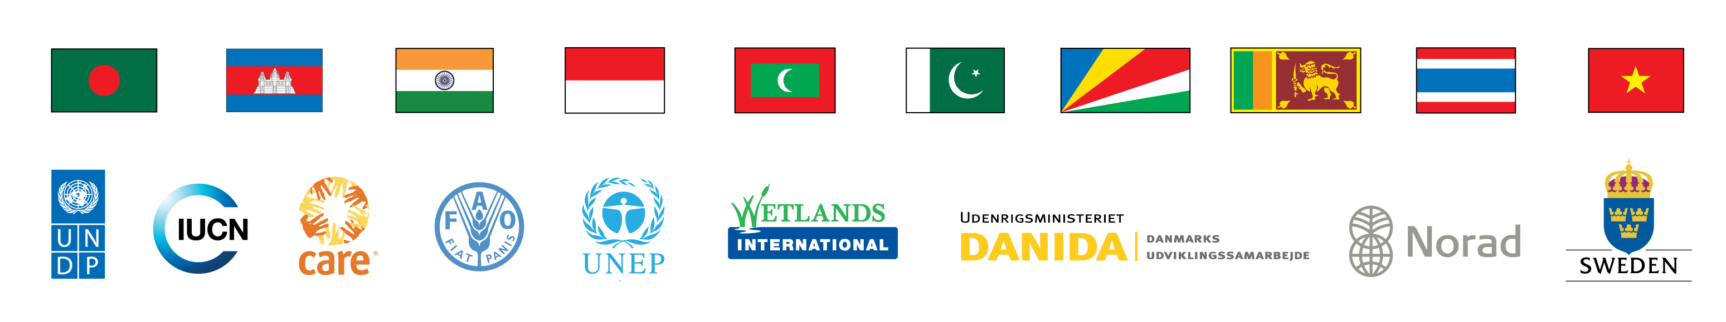

Reporting Templates for Small Grant Facility

Template 1. Progress Report for Small Grant Facility

Template 2. Financial Progress Report for Small Grant Facility

Template1:
Mangroves for the Future - Small Grant Facility Progress Report

Notes:
- The report should take into account all the impacts, outputs, and outcomes and for the entire project reporting period to date.
- Additional information may be provided as Annexes.

- Project Details

Project Title:
Project Number:
Project Duration: | Start date
Project Duration: | Original End date
Project Duration: | Final End date
Project Budget: | MFF Contribution | Counterpart funds
Project Budget: | USD XX,XXX | USD XX,XXX
Name of Organization:
Contact Details: (Including telephone or email)
Report Submitted by: (name and position)
Date of Report Submission:
Reporting period (check which apply): | - Q1 (first 3 months of project implementation)  - Q2 (second 3 month period)  - Q3 (third 3 month period)  - Final (fourth 3 month period)

- Executive Summary (max 2 pages)

- Background of the Project and Project Rationale
Not more than one page: Summarize the context and the problem in your project area, and why the project was necessary.
- Impacts of the project:
Describe the impacts brought about by the project. **Describe the positive and also negative impacts the project and activities have created.**
- Activities completed:
Outline the activities completed that produced the impacts in Section 4. Also, were there any changes in the planned activities and the actual activities? If yes, please explain. Was it necessary to undertake any activities that were not planned?
Explain if there were any major delays and the reasons for such delays.

- Achievement of Objectives and Results (=Outputs)
Using the Project’s logframe and Indicators table from your proposal, provide an assessment of the achievement of Objectives and Results. For the objective and each result please elaborate on:
- Progress towards meeting the objective and results. See example in table below. Were the project’s stated objectives and outputs achieved, not achieved or partially achieved? In the event of partial or non achievement, please explain the reasons.
- The extent to which the achievement of outputs and objectives have contributed to meeting the overall Goal of the project.
- Reflect on the logical links between Objective(s), Results and Activities (carrying out the planned activities may not always lead to achieving the stated outputs and achieving the outputs does not guarantee that the objectives are met).
Also include a statement of achievement of deliverables against the logframe or contract.
Example:

Intervention Logic | Objectively Verifiable Indicators (OVIs) | Source of Verification (SoV) | Progress Towards Achieving Objective and Results
Goal
Objective
Mangroves in commune A, Ha Tinh Province in Viet Nam are restored. | - Extent of healthy mangroves increased by x%/remain unchanged | - Commune administration reports | Healthy mangrove coverage increased by y%
Results
- A coastal protection zone of mangroves in Commune A, Ha Tinh Province is created | - Extent of new mangrove planting (x km²) | - Commune reports | y km² of mangrove planted thus far

- Cross-cutting issues:
How does the project address any of the 4 cross-cutting issues that are relevant to the project?
- climate change impacts
- gender equality
- conflict sensitivity
- property rights and resource tenure
- Interesting stories (1-2):
Each story should tell a story! Set the scene (what, who, where, when), describe what happened, and then say what was learned from the story and the conclusions so far.
The story should be “alive”, interesting and catchy. It should involve real people, so try to get direct quotes from people involved in the project (e.g., community X did such-and-such; Mrs Y learnt this and is now applying that; “As a result our family income has increased by Z%”, said Mrs Y).
- Communications and knowledge products
Please provide a table of publications, posters, brochures, photos, videos, etc. in the format below:
Description of the product  [type, no. of copies, publisher/producer etc.] | How was this product used?
- E.g., Video documentation of activity – 7-minute video; produced by Community A with XYZ Productions; 50 dvds produced | The video was shown during the quarterly district meeting, which involved the local town mayor and regional Ministry of Environment officer

- Major constraints and challenges
Please mention if there were any constraints and challenges in completing activities. Also mention if there were any positive or negative changes in circumstances that affected the activities or results/outcomes (example: political in/stability, natural, presence of other organizations doing similar works that you had not foreseen etc.)

- Lessons learnt
Please outline the lessons learnt from this project. The lessons learnt should reflect both technical lessons and the management lessons. If you were to do this project again, what would you improve?

- Policy recommendations, if any.
Provide recommendations, if any, for policy development.

- Final financial report (same as the template in progress report template)
Report expenses based on approved budget and what has been expended against individual budget lines/categories.
- ANNEXES (optional)
- Any material that you want to share and does not fit in the main body
- It is not mandatory to have annexes!

MFF Secretariat, IUCN Asia Regional Office, Bangkok
ver 03 Feb 2015

Template 2.
Financial Progress Report for Small Grant Facility

The icons below are embedded Excel worksheets. Double click on the icon, and it will open into an Excel worksheet. Please be patient, it will take a few seconds to load. You can begin to type directly onto the cells. When you are done, just save the Excel file normally and close. Your input will be saved automatically.
Sheet (A) SGF Finance Report is compulsory; it is the template for the project financial report. Sheet (B) SGF List of Transactions is optional; it will assist recording of project expenditures or transactions.

(A) (B)

MFF Secretariat, IUCN Asia Regional Office, Bangkok
ver 18 Feb 2015
MFF document tracking form
Required to be filled up by author of this document

Title | Reporting Templates for MFF Small Grant Facility Version 18 February 2015
Author | MFF Regional Secretariat
Date created | 2015-02-18
Main subject | Reporting Templates for SGF facility guidelines
Keywords | Templates, Report, SGF
Purpose | Guidance for MFF grant applicants
Summary | Template 1. Progress Report for Small Grant Facility  Template 2. Financial Progress Report for Small Grant Facility  Includes new SGF Progress Report Templates and financial report templates.
Distribution | MFF Website, Grants Page; MFF DMS
Date distributed | 2015-02-18

